User Routes

Register user - POST BASE_URL/user/register
Login user - POST BASE_URL/user/signin
Update user - PUT BASE_URL/user/update-profile - Token Required
Get user details - GET BASE_URL/user/getUserDetails - Token Required
Get all users - GET BASE_URL/user/getAllUsers
Get all Farmers - GET BASE_URL/user/getAllFarmers - Token Required

Registration Form Fields:

Farmer:
{
"role": "Farmer",
"firstName": "Shivam",
"lastName": "Choudhary",
"phone": "9680268582",
"gender": "male",
"password": "Shivam@123",
"village": "Sample Village",
"district": "Sample District",
"state": "Sample State",
"farmerCategory": "medium",
"cropsGrown": [
{
"cropName": "Wheat",
"season": "kharif",
"quantityProduced": "500 kg"
}
],
"landDetails": [
{
"plotId": "P001",
"area": 5,
"irrigationType": "well",
"soilType": "black"
}
],
"bankName": "BOI",
"ifscCode": "BOI000000001",
"accountNumber": "12345678910",
"soilHealthCard": pdf,
"labReport": pdf,
"govtSchemeDocs" : [pdf] Note: Farmer can upload multiple documents
}

Staff:
{
"role": "Staff",
"firstName": "Aniket",
"lastName": "Shelake",
"phone": "9373031080",
"gender": "male",
"password": "Aniket@123",
"village": "Sample Village",
"district": "Sample District",
"state": "Sample State",
"emailId": "aniket@test.com",
"joiningDate":"2025-12-10"
}

FPO:
{
"role": "FPO",
"firstName": "Varun",
"lastName": "Sharma",
"phone": "9826001412",
"gender": "male",
"password": "Varun@123",
"village": "Sample Village",
"district": "Sample District",
"state": "Sample State",
"gstNumber": "123456789",
"shopName":"Marjeevi FPO",
"emailId": "Varun@test.com"
}

Login by OTP:

Send OTP - POST BASE_URL/otp/send-otp
{
"mobile": "1234567890",
"role": "Farmer"
}

Verify OTP - POST BASE_URL/otp/verify-otp
{
"mobile": "1234567890",
"otp" : "547428",
"role" : "Farmer"
}

FPO Documents
1. seedLicense 2. fertilizerLicense 3. procurementLicense 4. GSTCertificate

Crop Listing Routes - Added by Farmer

Add crop listing - POST BASE_URL/crop-listing/add Token Required
Update crop listing - PUT BASE_URL/user/crop-listing/update/id Token Required
Delete crop listing - DELETE BASE_URL/crop-listing/delete/id Token Required
Get crop listing - GET BASE_URL/crop-listing/getListings
Get user specific crop listing - GET BASE_URL/crop-listing/getListingsByUser Token Required
Get specific crop from listing - GET BASE_URL/crop-listing/getCropByCropId/id Token Required
Get Receipt - GET BASE_URL/crop-listing/receipt/:id Token Required

Add crop listing

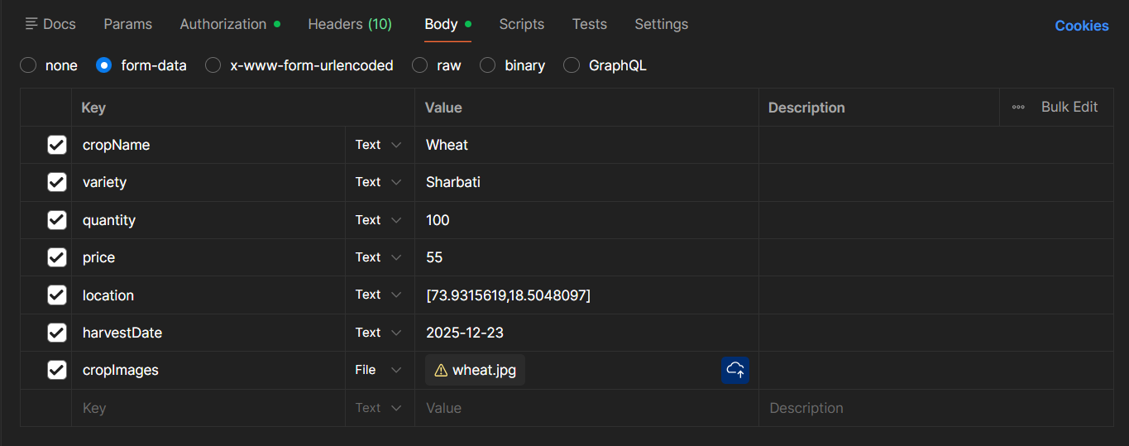

update crop listing - update any field that you want

Staff Procurement Routes

Add purchase record - POST BASE_URL/purchase/addPurchase Token Required
Update purchase record - PUT BASE_URL/purchase/updatePurchase/id Token Required
Delete purchase record - DELETE BASE_URL/purchase/deletePurchase/id Token Required
Get all purchase - GET BASE_URL/purchase/getPurchases Token Required
Get purchase by id - GET BASE_URL/purchase/getPurchaseById/id Token Required
Get purchase receipt - GET BASE_URL/purchase/receipt/id Token Required

Add purchase - by Staff
{
"farmer":"6955537b5397a9aee980a2ad",
"crop": "Wheat",
"rate": 55,
"quantity": 100,
"procurementDate" : "2026-01-05",
"procurementCenter": "Jaipur",
"godown": "",
"vehicle": "",
"remarks": "",
}

Update purchase - update any field that you want

Admin Product Routes - FPO

Add product - POST BASE_URL/product/addProduct Token Required
Update product record - PUT BASE_URL/product/updateProduct/id Token Required
Delete product record - DELETE BASE_URL/product/deleteProduct/id Token Required
Get all product - GET BASE_URL/product/getProducts
Get product by id - GET BASE_URL/product/getProductById/id
Toggle product state - PUT BASE_URL/product/toggleProductStatus/id Token Required

Add product - by FPO
{
"productName":"DAP Fertilizer",
"description" : null,
"mrp": 55,
"quantity": 100,
"unit": "bags",
"purchaseDate" : "2026-01-06",
"expiryDate": null
}

Update product - update any field that you want

Farm Routes - Farmer

Add farm - POST BASE_URL/farm/addFarm
Update farm - PUT BASE_URL/farm/updateFarmById/id
Delete farm - DELETE BASE_URL/farm/deleteFarmById/id
Get farm by farm-id - GET BASE_URL/farm/getFarmByFarmId/id
Get farms by user-id - GET BASE_URL/farm/getFarmsByUserId/id
Get all Farms - GET BASE_URL/farm/getAllFarms Token Required

Crop Routes - Farmer

Add user crop - POST BASE_URL/crop/addCrop Token Required
Update crop - PUT BASE_URL/crop/updateCrop/id Token Required
Delete crop - DELETE BASE_URL/crop/deleteCrop/id Token Required
Get user crops by user-id - GET BASE_URL/crop/getCropsByUser Token Required
Crop calendar - GET BASE_URL/crop/cropId/calendar

Add Crop - token required
{
"userId":"6955537b5397a9aee980a2ad",
"farmId":"6970fe96b76dff1d10dfb3dc",
"cropName":"Wheat",
"area":"0.50",
"unit":"acre",
"sowingDate":"2026-01-20"
}

Inventory Routes

Get inventory items - GET BASE_URL/inventory/get-all-items Token Required
Get inventory stocks - GET BASE_URL/inventory/stocks Token Required
Delete stock - DELETE BASE_URL/inventory/stock/itemId Token Required

Sell Routes

Get sells - GET BASE_URL/sell/get-sells Token Required
Sell products - POST BASE_URL/sell/get-sells

MarketPlace Routes

Get MarketPlace items - GET BASE_URL/marketplace/items

Cart Routes

Add to Cart - POST BASE_URL/cart/add Token Required
Get from cart - GET BASE_URL/cart/get-cart Token Required
Update cart - PUT BASE_URL/cart/update Token Required
Delete item from cart - DELETE BASE_URL/cart/remove/itemId Token Required
Clear cart - DELETE BASE_URL/cart/remove-all Token Required
Apply Coupon - POST BASE_URL/cart/apply-coupon Token Required (couponCode)

Add Item to cart -
{
"itemId": "695e237d12d085c231993c48",
"quantity": 10,
"expectedPrice": 450
}

Order Routes

Place order - POST BASE_URL/order/place
Get all orders - GET BASE_URL/order/allOrders
Update order status - PUT BASE_URL/order/updateOrderStatus/id Token Required
Get user specific orders - GET BASE_URL/order/myOrders Token Required
Generate order receipt - POST BASE_URL/order/generateReceipt/orderId Token Required
Get receipt by receipt id - GET BASE_URL/order/receipt/id Token Required
Download receipt by receipt id - GET BASE_URL/order/downloadReceipt/id Token Required
Get all Receipts - GET BASE_URL/order/allReceipts Token Required
Update Order Prices - PATCH BASE_URL/order/:id/update-prices Token Required

View Document API

Admin Routes
Get private files (for Admin) - GET BASE_URL/admin/files/private?type=soilHealthCard&userId=userid Admin Token Required

Create new staff - POST BASE_URL/admin/create-staff Admin Token Required

Get private files (for User) - GET
BASE_URL/user/files/private?type=labReport User Token Required

Type - labReport or soilHealthCard or govtSchemeDocs or seedLicense or fertilizerLicense or procurementLicense or GSTCertificate

Crop Doctor

Save Report - POST BASE_URL/crop-doctor/saveReport
Get user Reports - GET BASE_URL/crop-doctor/getUserReports/:userId
Get Report by id - GET BASE_URL/crop-doctor/getReportById/:reportId
Delete Report by id - GET BASE_URL/crop-doctor/deleteReport/:reportId

Chat bot

Chat - POST BASE_URL/chat/chatbot
Chat history - GET BASE_URL/chat/chatHistory/userid

Reports

Get monthly product inventory report - GET BASE_URL/reports/inventory/monthly?year=2026

Community (posts)

Create post - POST BASE_URL/posts/createPost Token Required
Update post - PUT BASE_URL/posts/updatePost/id Token Required
Delete post - DELETE BASE_URL/posts/deletePost/postId Token Required
Like the post - POST BASE_URL/posts/likePost
Dislike the post - POST BASE_URL/posts/dislikePost
Comment post - POST BASE_URL/posts/commentPost
Share post - POST BASE_URL/posts/sharePost
Get user specific post - GET BASE_URL/posts/getPostsByUserId/userId

FCM Broadcast Notification

Send announcement/broadcast - POST BASE_URL/broadcast/send FPO Token Required
Get broadcast statistics - GET BASE_URL/broadcast/stats FPO Token Required
Get broadcast history - GET BASE_URL/broadcast/history FPO Token Required
Get sender details - GET BASE_URL/broadcast/admin/id broadcastId Token Required
Get all broadcast - GET BASE_URL/broadcast/ Token Required
Get broadcast with id - GET BASE_URL/broadcast/id broadcastId Token Required

Send broadcast
form-data
{
title: Urgent Meeting,
description: Please join meeting at 7 PM,
targetRole: [Farmer, FPO, Staff, All],
broadcastImage: image
}

Coupon Routes

Add Coupon - POST BASE_URL/coupons/add Token Required
Update Coupon - PUT BASE_URL/coupons/update/id Token Required
Delete Coupon - DELETE BASE_URL/coupons/delete/id Token Required
Get all Coupons - GET BASE_URL/coupons/get-all Token Required

Add Coupon
{
"code": "SAVE20",
"discountType": "PERCENTAGE", ("PERCENTAGE", "FLAT")
"discountValue": 20,
"maxDiscount": 500,
"minOrderAmount": 1000,
"validFrom": "2026-03-10",
"validUntil": "2026-03-20"
}

Ledger Routes

Get all Ledgers - GET BASE_URL/ledger/ Token Required
Get Ledger By Reference Type - GET BASE_URL/ledger/reference/:type Token Required

Types -
PROCUREMENT,
PROCUREMENT_PAYMENT,
"SALE","PAYMENT",
"REFUND",
"ADJUSTMENT"

Advertisement Poster Routes

Add advertisement poster - POST BASE_URL/advertisement-posters/upload-poster Token Required (posterImages)
Get all advertisement poster - GET BASE_URL/advertisement-posters/
Delete advertisement poster - DELETE BASE_URL/advertisement-posters/:id/delete Token Required

Crop Calendar Routes

Get all crops data - GET BASE_URL/crop-calendar/
Get crop data by crop name - GET BASE_URL/crop-calendar/:cropName
Delete crop data by crop name - DELETE BASE_URL/crop-calendar/:cropName

Payment Routes

Farmer pays to FPO - POST BASE_URL/payment/farmer-payment
FPO pays to Farmer - POST BASE_URL/payment/fpo-payment
Payment balance - GET BASE_URL/payment/balance/farmerid

{
"farmerId" : "69bc26ac568a582dea41a343",
"amount" : 2000 ,
"paymentMethod" : "CASH"
}
paymentMethod - "CASH", "UPI", "BANK"

